Supervised learning:
Model is trained using labelled data.
Classification:
Categorising the data.
KNN, logistic regression, Decision tree, SVM
Regression:
Predicting a numerical value based on input features.
Linear regression, Polynomial regression.
Ex: Given area of a land predict its selling price.

Logistic regression:
Using numerical output value, we will categorise.
ex: Sigmoid function: if y<0.5 then 0 else 1
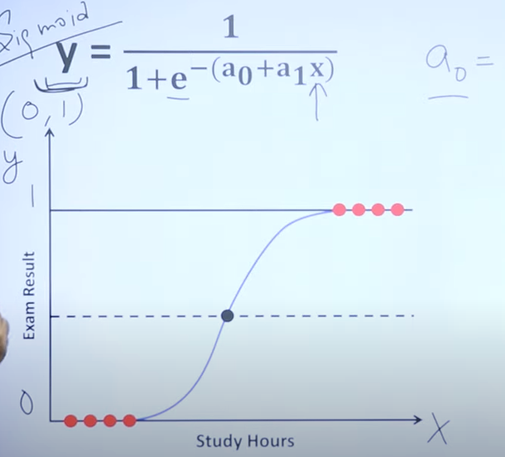

Decision tree classification:
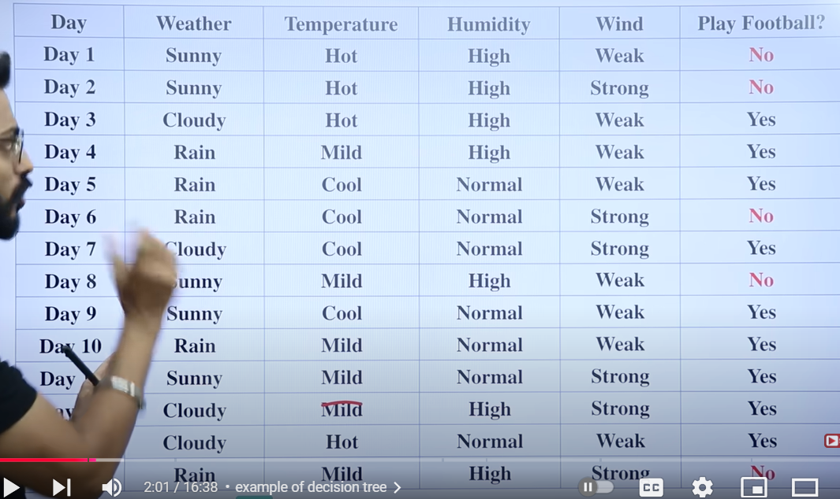
information gain of weather will be the highest among all attributes:
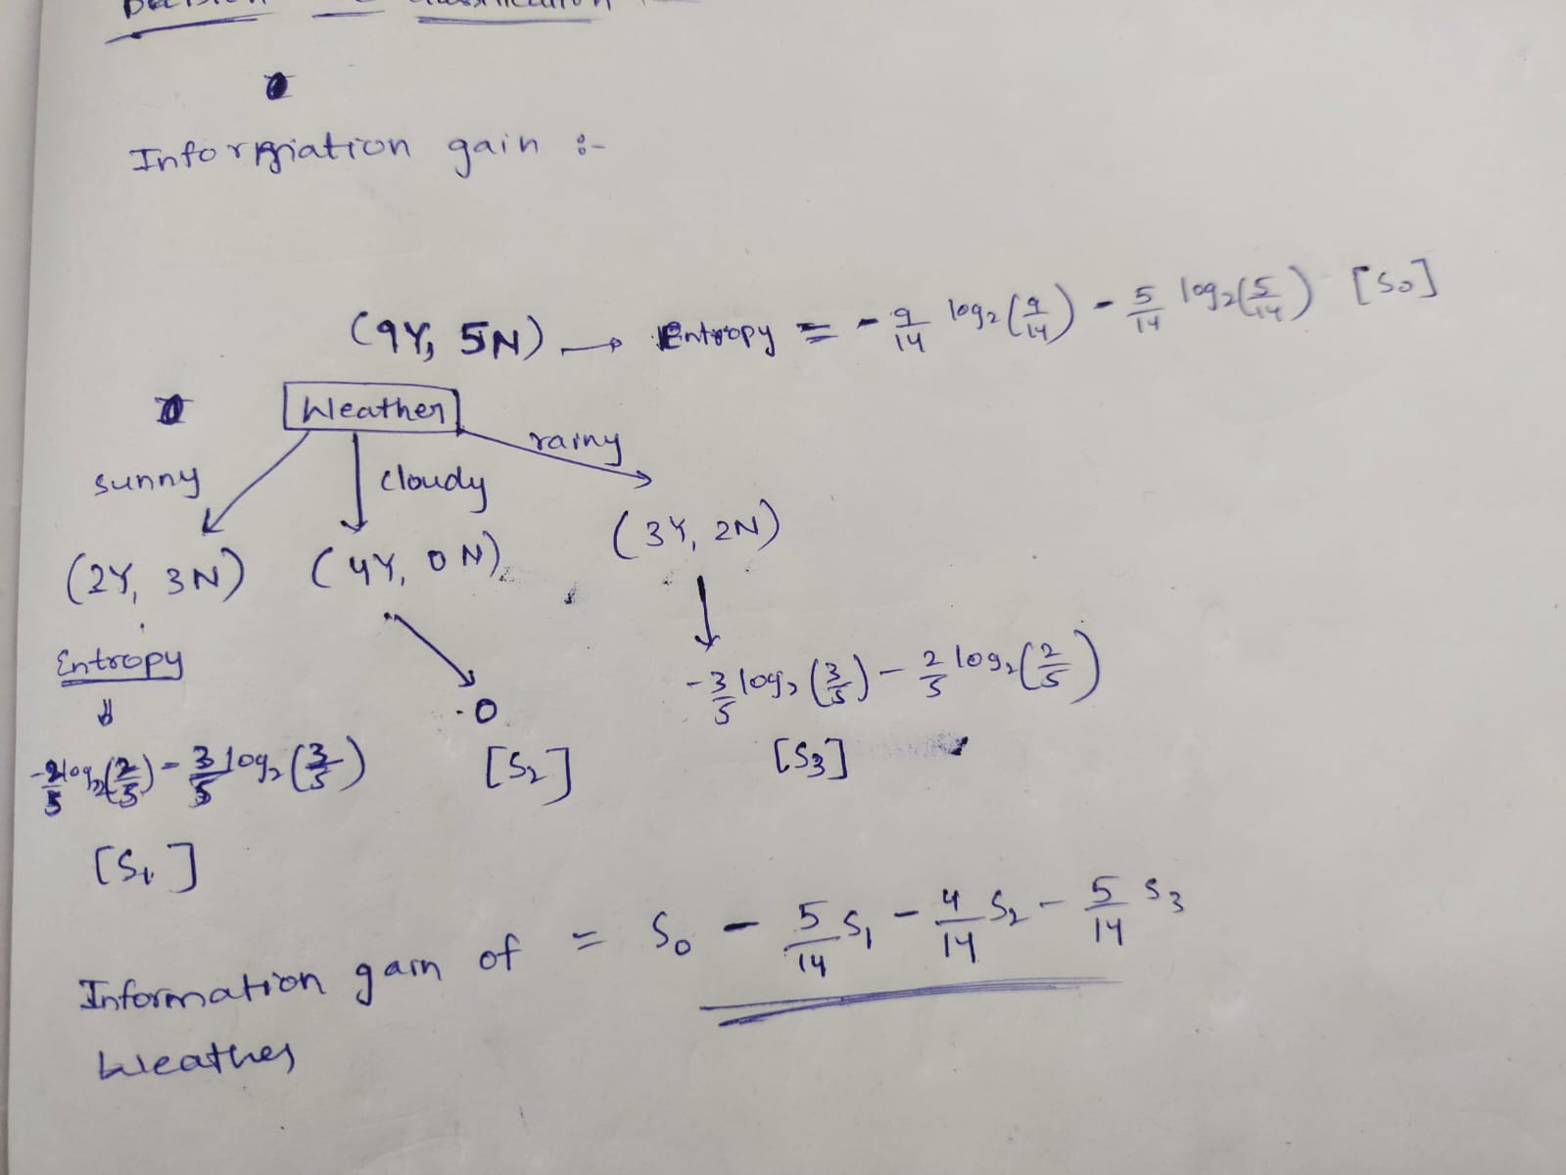
How Decision Trees Work?
- Selecting the Best Attribute:
Using a metric like Gini impurity, entropy, information gain, the best attribute to split the data is selected. The attribute with highest information gain is selected as a root node because high information gain indicates split with less impurity.
Entropy of pure split = 0
(3Y, 0N) = -(3/3)*log2(3/3) - (0/3)*log2(0/3) = 0
Entropy of impurest split = 1
(3Y, 3N) = -(3/6)*log2(3/6) – (3/6)*log2(3/6) = 1
- Splitting the Dataset: The dataset is split into subsets based on the selected attribute.
- Repeating the Process: The process is repeated recursively for each subset, creating a new internal node or leaf node until a stopping criterion is met (e.g., all instances in a node belong to the same class or a predefined depth is reached).

Decision trees leads to overfitting
Overfitting:
Overfitting occurs when a machine learning model learns too much from the training data, instead of focusing on the underlying patterns.
As a result, the model performs exceptionally well on training data but poorly on unseen (test) data.
when decision trees grow too deep, they capture minor details and noise in the training data.
As a result instead of focusing on underlying patterns it leans too much from trained data which leads to overfitting.

